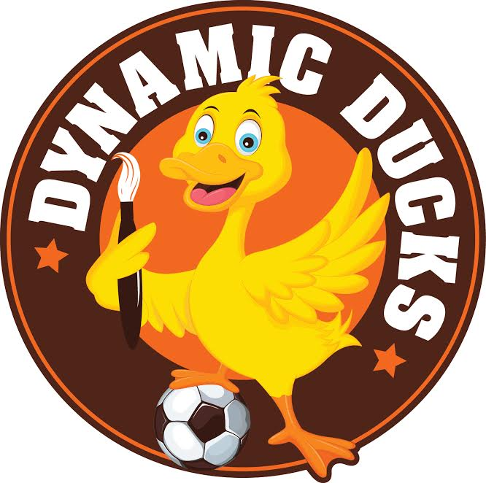
Dynamic Ducks Ltd
Children’s Survey

We would like to find out what you think about the Club and what we could do to make it better.

Please tick or colour in the face that shows how you feel about each question:
 = I like it a lot  = It’s OK  = I don’t like it

1. Do you enjoy the art and craft activities available at the club?
2. Do you like the drinks and snacks offered at the club?
3. Do you like the toys and board games at the club?
4. Do you like playing games outside at the club?
5. What do you think about the staff at the club?
6. What do you think about the place where the club is held? (This means the main room, outside play area, toilets etc)

7. What do you think is the best thing about the club? (please write below)

8. What do you like least about the club? (please write below)

9. If we could change one thing about the club to make it more enjoyable for you, what would it be? (please write below)

10. Do you talk to your friends and/or parents about the club?

